INTERNATIONAL LAW SEMINAR FOR AFRICAN UNIVERSITIES
KOFI ANNAN CENTRE, ACCRA, GHANA
15 TO 26 AUGUST 2016
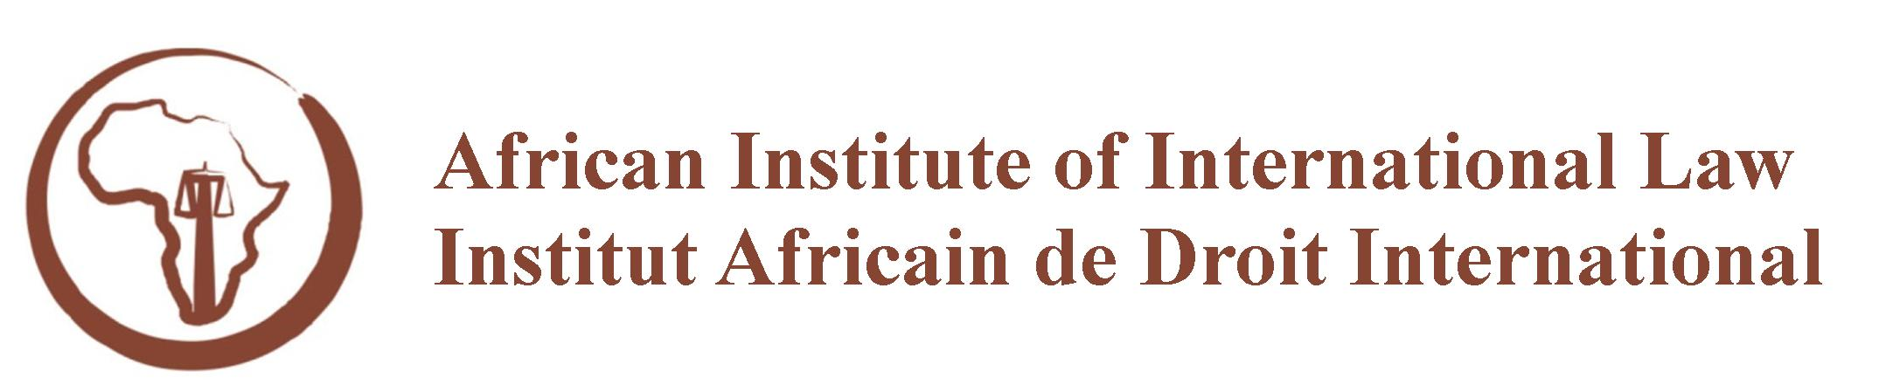

LECTURERS

International Law
Professor Sean Murphy
Member of the International Law Commission
George Washington University Law School
Washington, D.C., United States

International Organizations
UN Institutions and Law-making
Professor Makane Moïse Mbengue
University of Geneva
Geneva, Switzerland

African Union Law and Institutions
Professor Adelardus Kilangi
Former President, African Union Commission on International Law
Dean, Faculty of Law, St. Augustine University of Tanzania,
Mwanza, Tanzania

International Human Rights Law
African Human Rights Law and Institutions
Professor Obiora Okafor
Chair, United Nations Human Rights Council Advisory Committee
Osgoode Hall Law School, York University
Toronto, Canada

International Humanitarian Law
International Criminal Law
Judge Kevin Riordan
Judge Advocate General and Chief Judge of the Court Martial,
Former Director-General, Defence Legal Services, New Zealand Defence Force,
Lecturer, Victoria University of Wellington,
Wellington, New Zealand

