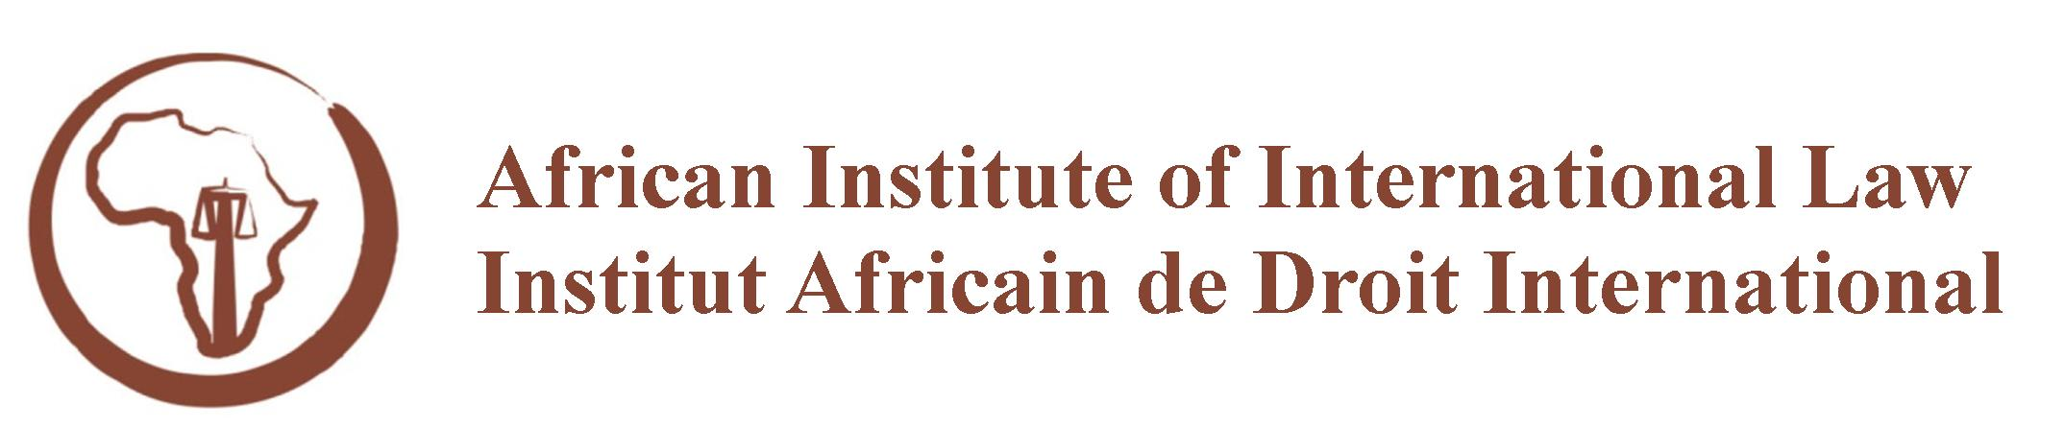

INTERNATIONAL LAW SEMINAR FOR AFRICAN UNIVERSITIES
KOFI ANNAN CENTRE, ACCRA, GHANA
15 TO 26 AUGUST 2016

Monday, 15 August | Tuesday, 16 August | Wednesday, 17 August | Thursday, 18 August | Friday, 19 August
Morning
9:00 - 12:00 | 9:00 - 12:00 | 9:00 - 12:00 | 9:00 - 12:00 | 9:00 - 12:00
International Law  Professor Murphy | International Law  Professor Murphy | International Organizations  Professor Mbengue | United Nations Institutions and Law-Making  Professor Mbengue | Workshop  Teaching  International law  Professor Mbengue
Afternoon
13:00 - 16:00 | 13:00 – 16:00 | 13:00 – 16:00 | 13:00 - 16:00 | 13:00 - 16:00
International Law  Professor Murphy | International Law  Professor Murphy | African Union Law  and Institutions  Professor Kilangi | African Union Law  and Institutions  Professor Kilangi | Workshop  Researching International Law  Codification Division

INTERNATIONAL LAW SEMINAR FOR AFRICAN UNIVERSITIES
KOFI ANNAN CENTRE, ACCRA, GHANA
15 TO 26 AUGUST 2016

Monday, 22 August | Tuesday, 23 August | Wednesday, 24 August | Thursday, 25 August | Friday, 26 August
Morning
9:00 - 12:00 | 9:00 - 12:00 | 9:00 - 12:00 | 9:00 - 12:00 | 9:00 - 12:00
International Human Rights Law  Professor Okafor | African Human Rights Law and Institutions  Professor Okafor | International Humanitarian Law  Judge Riordan | International Criminal Law  Judge Riordan | Workshop  Teaching  International Law
Afternoon
13:00 - 16:00 | 13:00 - 16:00 | 13:00 - 16:00 | 13:00 - 16:00 | 13:00 - 16:00
International Human Rights Law  Professor Okafor | African Human Rights Law and Institutions  Professor Okafor | International Humanitarian Law  Judge Riordan | International Criminal Law  Judge Riordan | Closing ceremony

